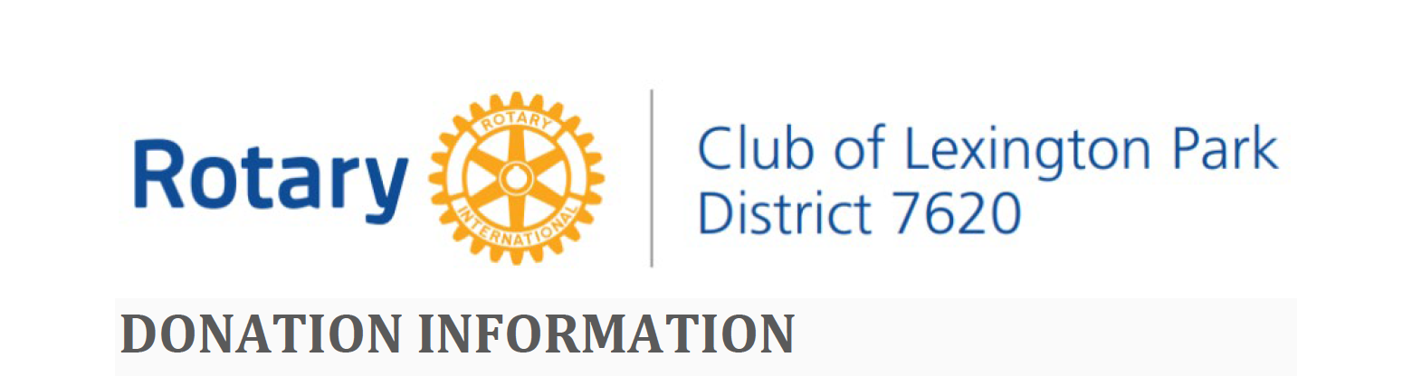
DONATION INFORMATION
Charitable Projects Lane
Jane Sypher, Lane Director
The Charitable Projects Lane, known as the Community Service Lane in Rotary, is one of the four key lanes of service in Rotary. Rotary International is renowned for not only its global services, but for working at the community level. The Rotary Club of Lexington Park honors that tradition.
CHARITY RESEARCH, DONATIONS and GRANTS
The Charity Research committee is the arm of the Club that seeks and qualifies eligible local charities whose missions and needs align with those specified by the Charity Lane and approved by the Rotary Board. In FY22, the Charity Research Committee focuses specifically on three community areas of need: Home Insecurity and Homelessness; Mental Health for St. Mary’s Youth; and Nutrition Insecurity. During the year, Club grants and donations are given to organizations that support these priorities by increasing or beginning projects in the three areas. Overall charitable giving averages $25K to $30K per year. All charitable funds are managed through the Foundation of the Rotary Club of Lexington Park. This fund is supported through generous donations and the club’s fund-raising initiatives.
CHARITABLE PROGRAM DESCRIPTION
The mission of the Rotary Foundation is to enable Rotarians to advance world understanding, goodwill, and peace through the improvement of health, the support of education, and the alleviation of poverty. The Rotary Foundation is a not-for-profit corporation supported solely by voluntary contributions from Rotarians and friends of the foundation who share its vision for a better world. Likewise, the Rotary Club of Lexington Park operates through a club foundation with similar aims within our community.
The Rotary Club of Lexington Park is comprised of volunteers who work locally to fight hunger, improve living conditions, improve the quality of life of community citizens, provide education opportunities, promote peace, and support the Rotary International efforts in eradicating polio all under the motto, “Service Above Self”.
This club supports the community by providing charity funding for organizations needing assistance in three specific areas: Homelessness and Housing Insecurity, Nutrition Insecurity, and Mental Health for St. Mary’s Youth. Our charity program involves two levels of donations.
- If your organization’s mission and need are within the realm of at least one of these three areas and your request is $3,000 or less, we invite you to complete the linked RCLP Donation/Support Application Form as a Word Document and submit it electronically to charity@rotarylp.org (RCLP Donation/Support Application Form as an adobe .pdf file).
- If your organization’s mission and need are within the realm of at least one of these three areas and your request is greater than $3,000, we invite you to complete the linked RCLP Grant Application Form as a Word Document and submit it electronically to charity@rotarylp.org (RCLP Grant Application Form as an Adobe .pdf file).
Please ensure all parts of the applications are complete. Your organization will be notified of a decision within 30 days of receipt of the request. Information about our Charitable Grant Program is contained below the photo.
GRANT SUPPORT FOR PROJECTS
The committee has adopted guidelines that are used to evaluate grant project applications. The guidelines include a list of objectives and attributes which the committee desires to obtain in the projects it supports. Our grantmaking program supports a wide variety of community needs and causes with one end goal in mind: improving the quality of life in St. Mary’s County. Applicants must identify the specific impact that their organization will have on St. Mary’s County.
In FY22, we are funding outcomes for programs, organizations, or systems that address:
- Home Insecurity and Homelessness
- Mental Health Services for St. Mary’s County Youth
- Nutrition Insecurity
The programs and projects supported will generate sustainable solutions that leave a lasting impact for the citizens of St. Mary’s County.
To apply for funding under these Strategic Initiatives, applicants must identify project or service
outcomes for programs, organizations, or systems that address:*
- Increased opportunities to reduce or eliminate home insecurity and homelessness in St. Mary’s County
- Continued or increased opportunities to address the mental health needs of St. Mary’s County Youth
- Increased opportunities to reduce or eliminate nutrition insecurity in St. Mary’s County
* Requests outside of these areas may be considered when they meet additional needs within our community.
General Requirements:**
- Established, non-profit IRS tax-exempt status
- Programs/Projects with a specific purpose and articulated outcomes that support RCLP’s strategic community needs
- Programs/Projects that have a positive track record and a realistic chance for continued success
- Programs/Projects within the Club’s local service area: Lexington Park and St. Mary’s County
- Organizations willing to acknowledge, publicly support and cross-promote the Rotary Club of Lexington Park to build increased community awareness of our efforts to support our community.
** Worthy or compelling requests that do not fit the adopted requirements may be considered.
Program Criteria
Funding preference is given to programs and projects that:
- Are well planned
- Show a direct, measurable impact to the community in RCLP’s priority areas
- Make a significant impact for money spent (e.g. fishing poles as opposed to fish)
- Leverage Rotary funds to secure matching grants and other means of support from additional sources
- Engage in effective collaboration/partnerships to maximize impact
- Are sustainable and include opportunities for members of RCLP to actively participate. Rotary is built on service and as a club we strive to be present in the community where we invest and not just serve as a check writer.
- Can assist RCLP in its annual fundraising efforts
Reporting
All projects that are funded are requested to supply a report to the Rotary Club of Lexington Park within 30 days of the conclusion of the event/project that includes the following:*
- Specific use of the donation/grant and information relative to the sustainability of the project
- Press release concerning the event/project that acknowledges the contribution of the Rotary Club of Lexington Park, including Rotary members’ participation in the project
- Photograph(s) of the event/project.
*Additionally, the club may request a follow-up presentation at a regularly scheduled Rotary meeting
Application Period
Grant applications will be accepted during the period of January 1, 2022 through December 31, 2022.
Grant Disbursement
Grants will be disbursed in one payment during the first 30 days of the grant period. Funding is restricted to supporting activities and expenses outlined in the grant application.

